**EC2**

1. **Instances and types**

**Types of EC2 Instances Categories:**

Amazon EC2 instances are categorized based on their **purpose and resource optimization**:

**1. General Purpose Instances**

* **Description**: Balanced compute, memory, and networking. Suitable for a variety of workloads.
* **Example Use Cases**: Web servers, app servers, and development environments.
* **Examples**:
  + M-series: M7i, M7g, M7a, M6i, M6g, M6a, M5, M5a, M5n, M4
  + T-series: T4g, T3, T3a, T2
  + Mac-series: Mac2, Mac1



**2. Compute Optimized Instances**

* **Description**: Optimized for compute-intensive tasks with high-performance processors.
* **Example Use Cases**: High-performance computing (HPC), scientific modeling, and batch processing.
* **Examples**:
  + C-series: C7i, C7g, C7a, C7gn, C6i, C6g, C6a, C6gn, C5, C5a, C5n, C4



**3. Memory Optimized Instances**

* **Description**: Designed for workloads requiring high memory and fast performance.
* **Example Use Cases**: Databases, in-memory caching, and real-time big data analytics.
* **Examples**:
  + R-series: R7i, R7g, R7a, R7iz, R6i, R6g, R6a, R5, R5a, R5b, R5n, R4
  + X-series: X2idn, X2iedn, X2iezn, X1e, X1
  + High Memory: u-6tb1, u-9tb1, u-12tb1, u-18tb1, u-24tb1
  + Z-series: Z1d



**4. Storage Optimized Instances**

* **Description**: Designed for workloads requiring high-speed, low-latency storage.
* **Example Use Cases**: Data warehousing, NoSQL databases, and large-scale data processing.
* **Examples**:
  + I-series: I4i, I4g, I3, I3en
  + D-series: D3, D3en, D2
  + H-series: H1



**5. Accelerated Computing Instances**

* **Description**: Uses GPUs or FPGAs for compute-intensive tasks like machine learning and graphics rendering.
* **Example Use Cases**: Machine learning inference/training, video processing, and scientific computations.
* **Examples**:
  + P-series: P5, P4, P3 (GPU instances for ML/HPC)
  + G-series: G6, G5, G5g, G4dn, G4ad (Graphics-intensive)
  + Inf-series: Inf2, Inf1 (AWS Inferentia for ML inference)
  + Trn-series: Trn1, Trn1n (AWS Trainium for ML training)
  + F-series: F1 (FPGA instances)
  + VT-series: VT1 (Video transcoding)
  + DL-series: DL1, DL2q (Deep learning) Each series has multiple sizes (e.g., c7i.large, c7i.xlarge, c7i.2xlarge) to match your specific resource needs.

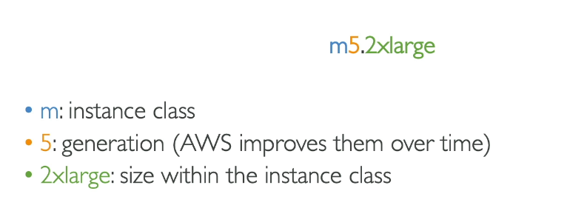

**Pricing Models in Amazon EC2 (Explained with Real-Time Examples)**

AWS EC2 offers flexible pricing models designed to suit various workload types and usage patterns. Here’s a detailed explanation of each pricing model with real-world scenarios:



**1. On-Demand Instances**

* **What It Means**:  
  You pay for compute capacity by the second or hour without any long-term commitment. Pricing is higher than other models but offers flexibility.
* **Use Case**:  
  Best for **short-term, unpredictable workloads** or when you’re testing applications.
* **Real-Time Example**:  
  Imagine you're a **developer working on a new app** and need an EC2 instance to test your code. The workload is unpredictable because you don’t know how much time you’ll need. Using **On-Demand Instances**, you can start and stop your EC2 instance whenever needed, and you’re billed only for the time it’s running.

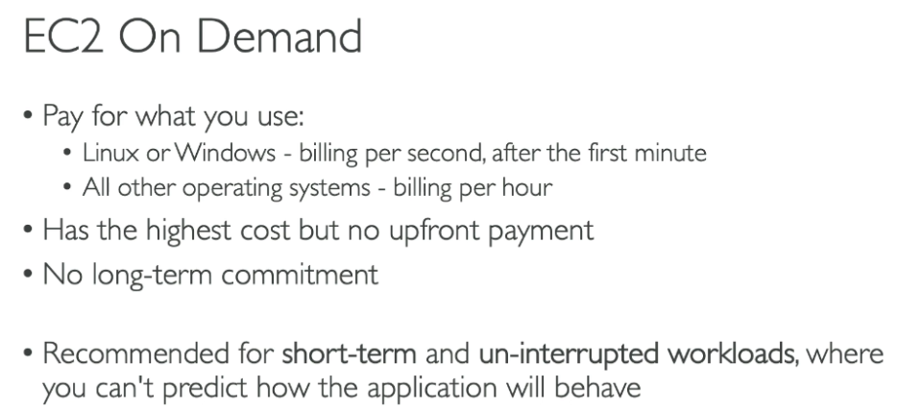



**2. Reserved Instances (RIs)**

* **What It Means**:  
  By committing to use an EC2 instance for **1 or 3 years**, you receive a **significant discount** (up to 75%) compared to On-Demand pricing. Reserved Instances are best for workloads with predictable usage.
* **Use Case**:  
  Ideal for **steady-state workloads** that run continuously, such as databases or web servers.
* **Real-Time Example**:  
  A **company hosting a web application** for their business knows the application will run 24/7 for at least 2 years. By purchasing a Reserved Instance for 3 years, they save significantly on hosting costs compared to paying On-Demand rates.



**3. Spot Instances**

* **What It Means**:  
  Spot Instances allow you to purchase unused EC2 capacity at **discounted rates (up to 90%)**. These instances can be interrupted by AWS when the capacity is needed by On-Demand users.
* **Use Case**:  
  Perfect for **non-critical, fault-tolerant workloads**, such as batch processing or machine learning model training.
* **Real-Time Example**:  
  A **video rendering company** needs to process high volumes of video files for clients. By using Spot Instances, they can queue rendering jobs and process them at a fraction of the cost, even if the instances are interrupted and jobs are re-queued.

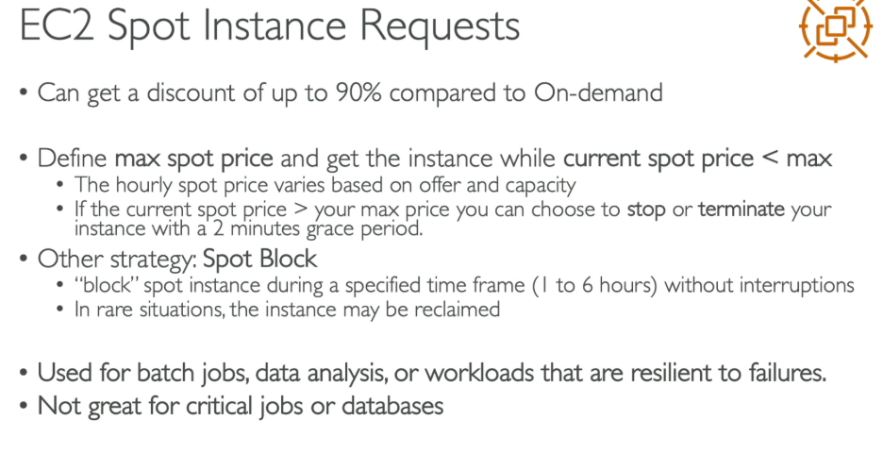



**4. Dedicated Instances**

* **What It Means**:  
  These instances run on physical servers **dedicated exclusively to a single customer**, ensuring isolation from other AWS customers. Pricing is higher but necessary for workloads with **strict compliance or regulatory requirements**.
* **Use Case**:  
  Ideal for businesses with **compliance requirements**, such as handling sensitive healthcare or financial data.
* **Real-Time Example**:  
  A **hospital managing patient records** under HIPAA regulations needs strict data isolation. They opt for Dedicated Instances to comply with legal and security standards, ensuring their server is not shared with other AWS customers.



**5. Savings Plans**

* **What It Means**:  
  A **flexible pricing model** that provides discounts (up to 66%) in exchange for a **commitment to a certain level of usage** (measured in $/hour) over 1 or 3 years.
* **Use Case**:  
  Best for customers who want **flexibility** across instance families, regions, or operating systems, while still saving money.
* **Real-Time Example**:  
  A **software-as-a-service (SaaS) company** uses multiple types of EC2 instances across different regions for their global clients. By committing to spend $500/month on compute capacity for 3 years through a **Compute Savings Plan**, they receive a discount and maintain flexibility in how they use their EC2 instances.

**When to Choose Reserved Instances:**

1. Service Coverage

* RIs cover services that Savings Plans don't:
  + Amazon RDS (databases)
  + Amazon Redshift (data warehouse)
  + Amazon ElastiCache (caching)
  + Amazon OpenSearch Service
  + DynamoDB

2. Capacity Reservation

* Zonal RIs guarantee capacity in a specific Availability Zone
* Critical for mission-critical workloads that need guaranteed capacity
* Savings Plans don't reserve capacity

3. Resale Option

* Standard RIs can be sold in the Reserved Instance Marketplace
* Recover costs if your needs change
* Savings Plans cannot be resold 4. Predictable, Stable Workloads
* If you know exactly which instance type you'll use for 3 years
* No need for flexibility = maximize savings with Standard RIs

5. Database Workloads

* RDS Reserved Instances are the only discount option for databases
* Savings Plans don't cover RDS

Bottom Line:

* Choose Savings Plans: For EC2 compute flexibility
* Choose Reserved Instances: For RDS, Redshift, ElastiCache, capacity guarantees, or resale options Many organizations use both - Savings Plans for flexible compute and RIs for databases and other services!

**When to Choose Savings Plan:**

You should consider Savings Plans when: 1. Steady-State Workloads

* You have consistent, predictable compute usage that runs continuously
* Examples: production applications, databases, web servers that are always on

2. Need Flexibility

* You want to change instance types, sizes, or families without losing discounts
* Your architecture evolves and you need adaptability
* You use multiple instance types across different projects

3. Multi-Region Operations

* Your workloads span multiple AWS Regions
* Compute Savings Plans apply across all Regions automatically

4. Mixed Compute Services

* You use a combination of:
  + Amazon EC2
  + AWS Fargate
  + AWS Lambda
* Compute Savings Plans cover all three services

5. Cost Optimization Priority

* You want significant savings (up to 72%) over On-Demand pricing
* You can commit to a consistent hourly spend for 1 or 3 years

6. Simplified Management

* You prefer dollar-based commitments over managing specific instance reservations
* You want automatic application of discounts without manual intervention

**In savings plan, is it possible to change to m5.Large to t3.Micro or to some other instances?**

Yes, it is possible to change instance types with Savings Plans, but the flexibility depends on which type of Savings Plan you have:

Compute Savings Plans provide the most flexibility - you can change between any instance families, sizes, regions, operating systems, and tenancy. For example, you can move from m5.large to t3.micro and still receive the Savings Plans discount.

EC2 Instance Savings Plans offer less flexibility - you can only change instance sizes, operating systems, and tenancy within the same instance family in a specific region. For example, you could change from m5.large to m5.xlarge, but you cannot change from m5.large to t3.micro since they are different instance families (M5 vs T3). Note that Savings Plans do not apply to Spot Instances. The plans automatically apply their discounted rates to your eligible usage based on the plan type you've purchased.

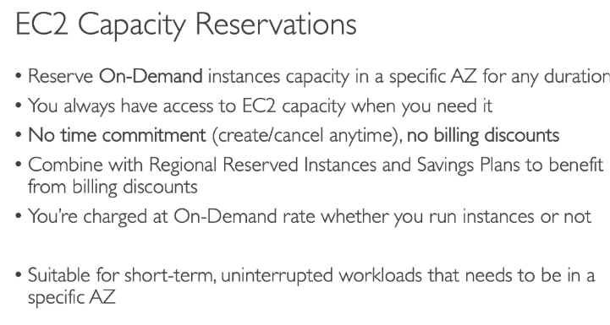

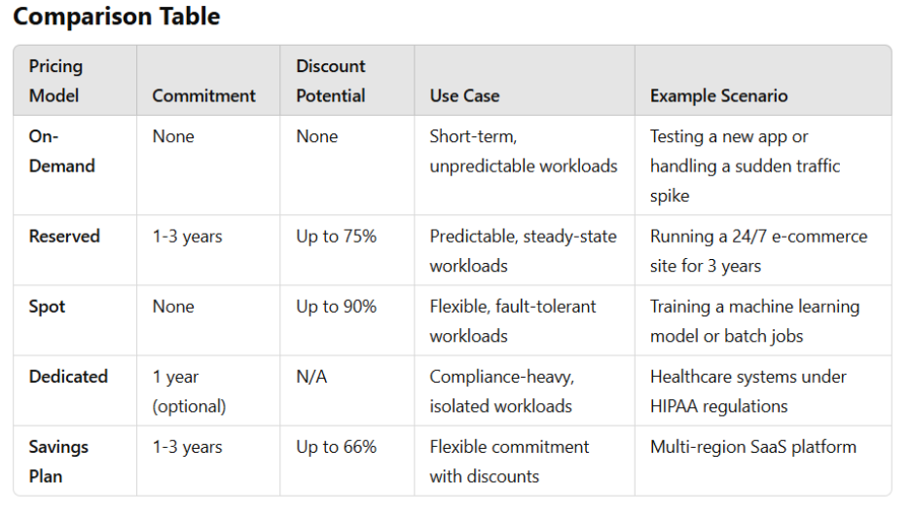

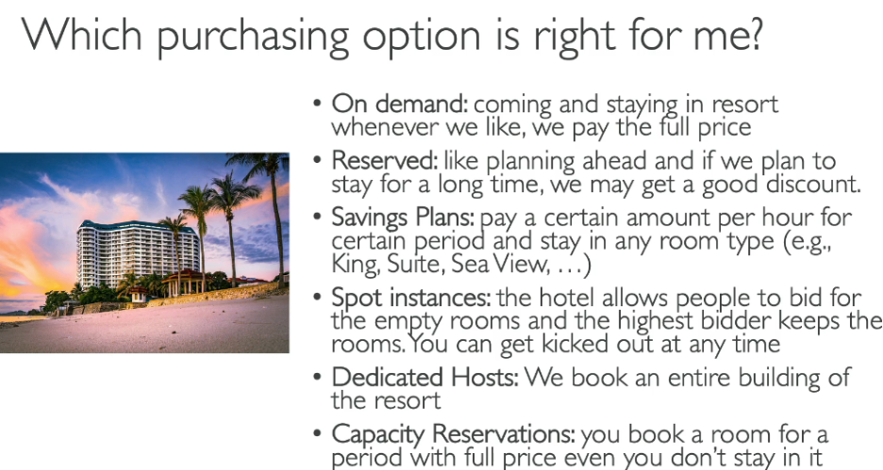

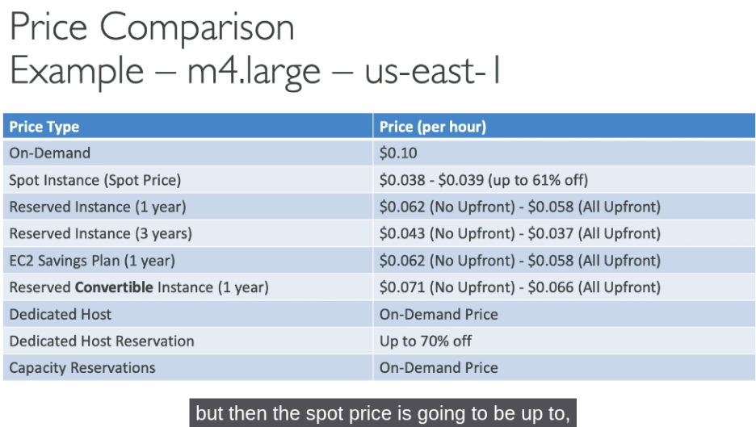

1. **Launch Templates**
2. **Spot Requests**
3. **Capacity reservation**

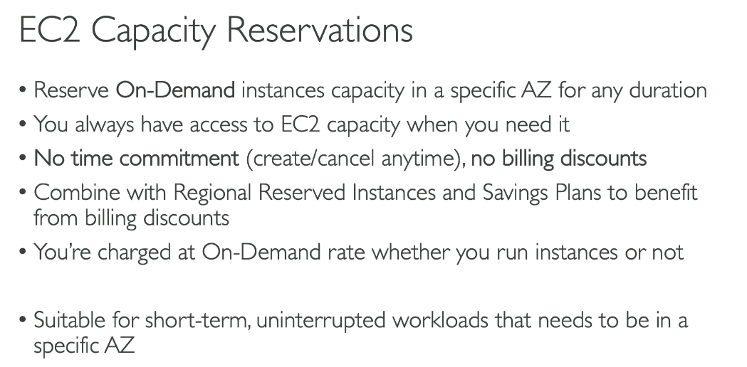

1. **Capacity manager**

Amazon EC2 Capacity Manager is a centralized solution that helps you monitor, analyze, and manage your EC2 capacity usage across all AWS accounts and Regions from a single interface.

Key Features:

1. Unified Dashboard - Consolidates capacity data for On-Demand Instances, Spot Instances, and Capacity Reservations in one location, eliminating the need to navigate between multiple AWS services
2. Cross-Account & Cross-Region Visibility - View capacity metrics across all commercial AWS Regions and multiple accounts (when integrated with AWS Organizations)
3. Hourly Data Refresh - Aggregates historical data with hourly updates, including 14 days of historical data during initial setup
4. Cost Optimization Insights - Identifies opportunities to:
   1. Discover underutilized Capacity Reservations
   2. Analyze usage patterns across instance types
   3. Review Spot Instance interruption patterns
   4. Make informed decisions about rightsizing infrastructure

How to Enable:

1. Navigate to Amazon EC2 in the AWS Management Console
2. Select Capacity Manager from the navigation pane
3. Enable through service settings

Important Notes:

* Can only be enabled in one AWS Region per account
* Cost estimates shown are based on On-Demand pricing and don't include discounts like Savings Plans or Reserved Instances
* Designed for large enterprises and multi-account organizations

1. **AMI**

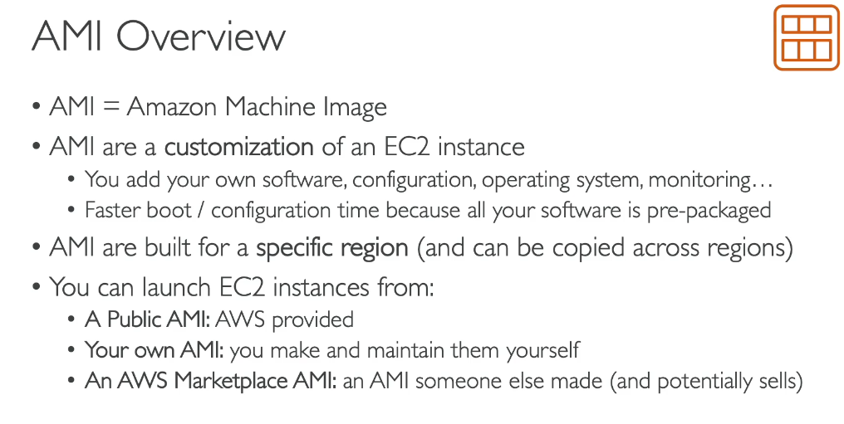

1. **Volumes**

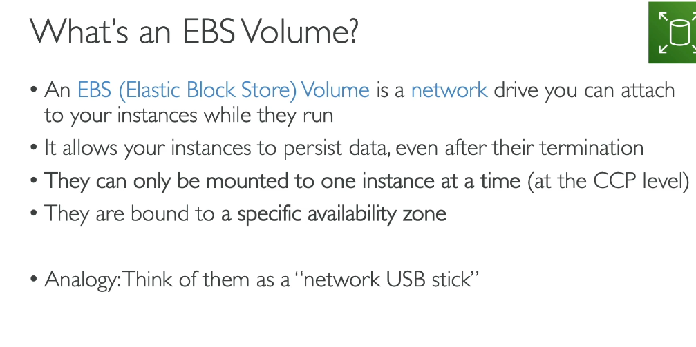

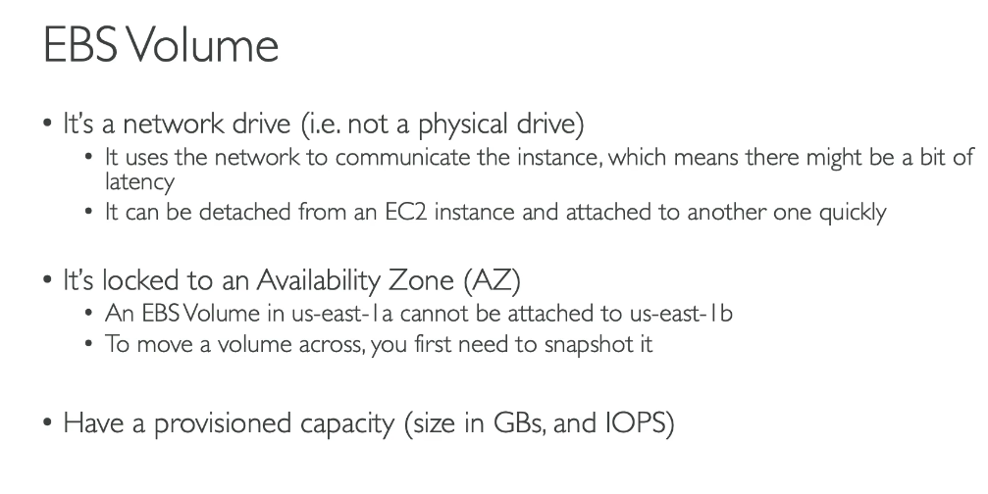

**Can EBS Volumes be attached with 2 instances at the same time?**

Standard EBS Volumes:

* Can be attached to only ONE instance at a time
* This is the default behavior for all EBS volume types

Multi-Attach Capability:

* Available for Provisioned IOPS (io1 and io2) volumes only
* Allows attaching a single volume to up to 16 EC2 instances simultaneously
* All instances must be in the same Availability Zone
* Instances must be Nitro-based (Linux only)
* Multi-Attach won't work in root volumes, which means you can't attach the root volume to another instance parallelly even if it is io1 or io2.

Multi-Attach Use Cases:

* High-availability clustered applications
* Applications requiring concurrent write access
* Shared storage for multiple instances

How to Enable Multi-Attach:

* For io2 volumes: Can enable during creation OR after creation (if not attached)
* For io1 volumes: Must enable during creation only

Important Notes:

* Each Nitro-based instance can have multiple Multi-Attach enabled volumes
* Your application must manage write ordering to maintain storage consistency
* Supports snapshots and encryption just like regular volumes

Bottom Line: Standard EBS volumes = one instance only. Need multiple instances? Use Multi-Attach with io1/io2 volumes!

1. **Snapshot**

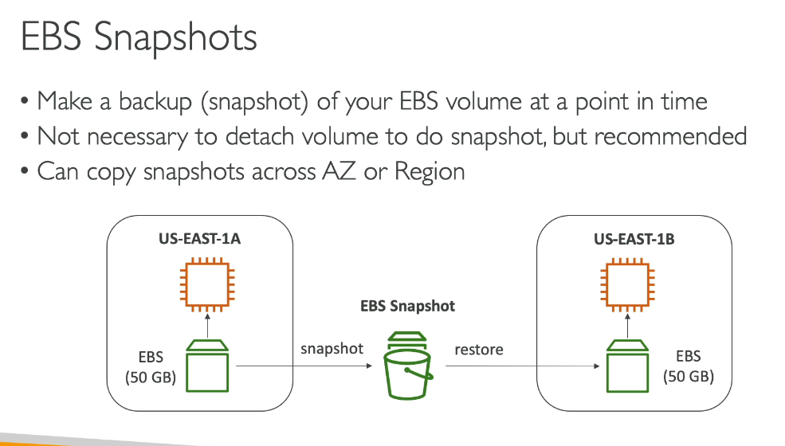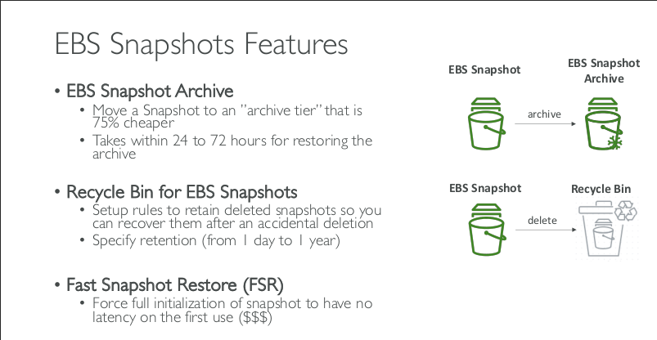

1. **Lifecycle Manager**

Amazon Data Lifecycle Manager (DLM) for EBS automates the creation, retention, and deletion of EBS snapshots and Amazon Machine Images (AMIs), eliminating the need for custom scripts to manage your backup lifecycle.

Key Uses:

1. Automated Backup Scheduling - Create snapshots of EBS volumes automatically at regular intervals using custom schedules or cron expressions, ensuring consistent data protection without manual intervention
2. Compliance & Data Retention - Enforce backup policies to meet regulatory and compliance requirements by automatically retaining backups for specified periods and deleting old snapshots to control costs
3. Disaster Recovery - Set up policies to automatically copy snapshots to other AWS Regions or accounts for disaster recovery purposes
4. Cost Management - Automatically delete outdated snapshots based on retention rules, preventing unnecessary storage costs from accumulating
5. AMI Lifecycle Management - Automate the sharing, deprecation, and deregistration of AMIs, with automatic deletion of underlying snapshots when AMIs are deregistered
6. Application-Consistent Backups - Support for pre-scripts and post-scripts to create application-consistent snapshots for databases running on EC2 instances

How to Get Started:

1. Tag your EBS volumes or EC2 instances
2. Create lifecycle policies in the EC2 console under Elastic Block Store > Lifecycle Manager
3. Define schedule, retention rules, and target resources
4. Monitor policy execution through CloudWatch Events and CloudTrail

Benefits: No additional cost for using Data Lifecycle Manager, and it's compliant with SOC, PCI, FedRAMP, ISO, and HIPAA-eligible.

1. **Security groups**

**Classic Ports:**

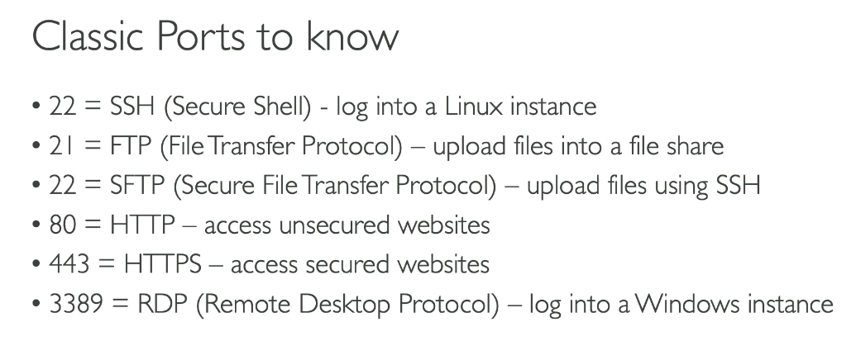

|  |  |
| --- | --- |
| **Service** | **Port** |
| SSH | **22** |
| RDP | **3389** |
| HTTP | **80** |
| HTTPS | **443** |
| DNS | **53** |
| MySQL | **3306** |
| PostgreSQL | **5432** |
| SMTP | **25** |
| SNMP | **161** |
| LDAP | **389**, LDAPS = **636** |
| NFS | **2049** |

1. **Elastic IP’s**

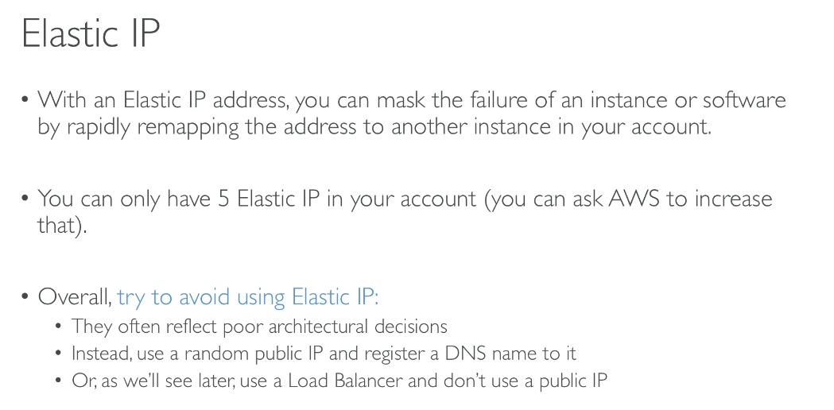

1. **Placement groups**

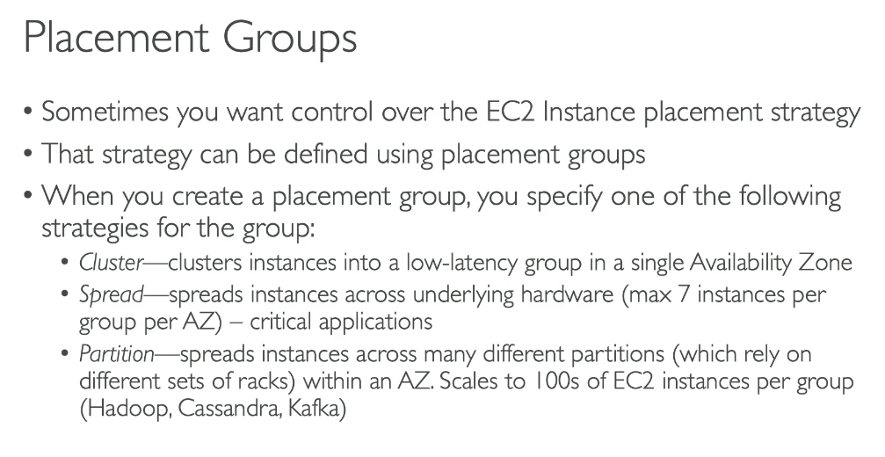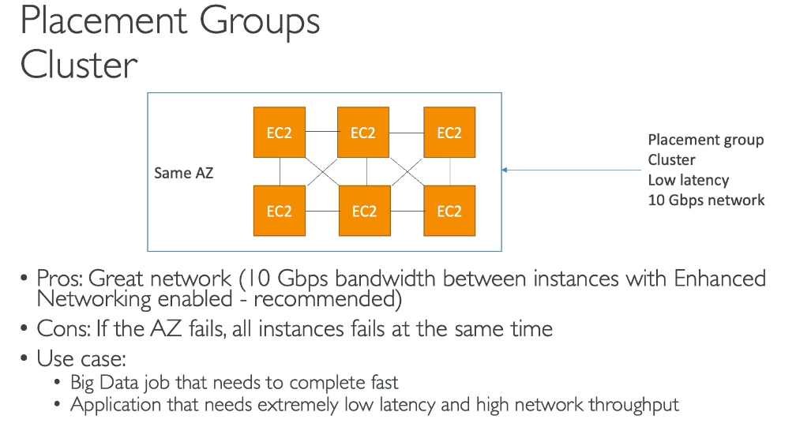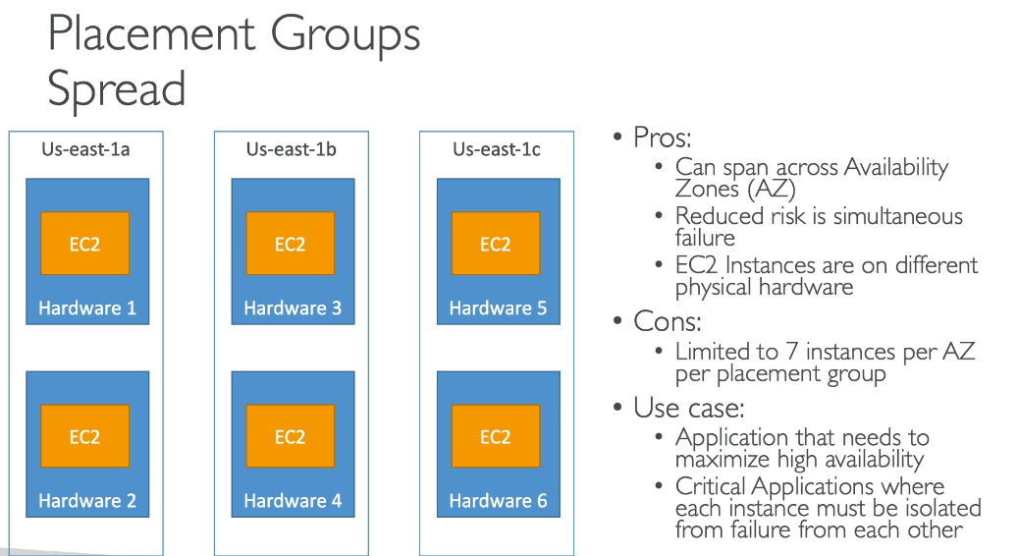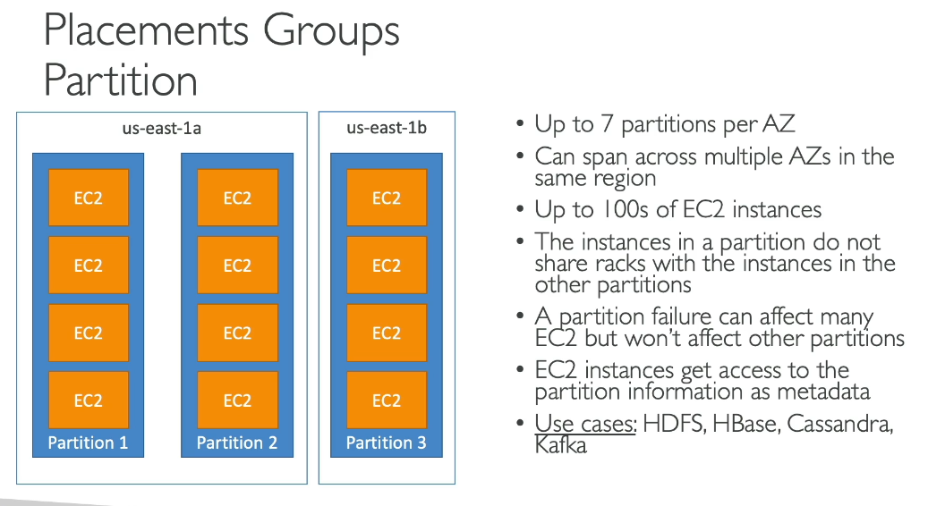

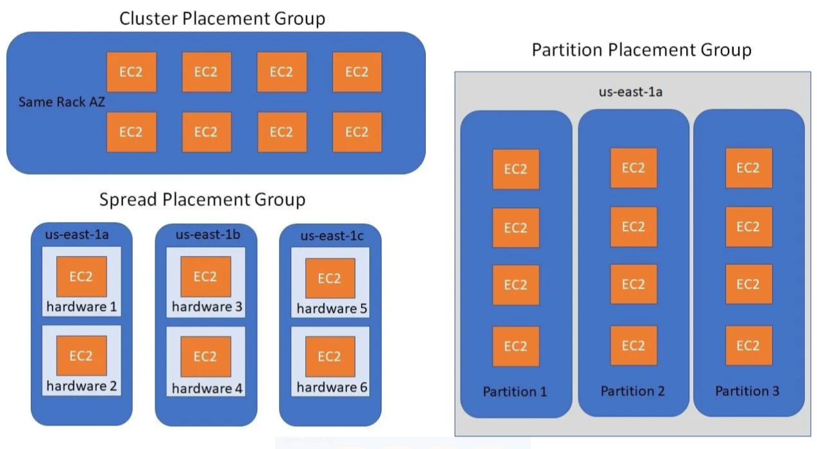

1. **Key Pair**

There should not be spaces in the Key pair name.

**Types**

* 1. RSA
  2. ED25519 – Not Supported for Windows instance

**Private Key File Format:**

1. .ppk - For PuTTY
2. .pem - For OpenSSH

**Chmod 400 example.pem**

|  |  |  |
| --- | --- | --- |
| **Scope** | **Value** | **Meaning** |
| Owner | 4 | ✅ Read only |
| Group | 0 | ❌ No access |
| Others | 0 | ❌ No access |

Read – 4

Write – 2

1. **Network Interfaces**

A detachable, reusable network card for your EC2 instance.

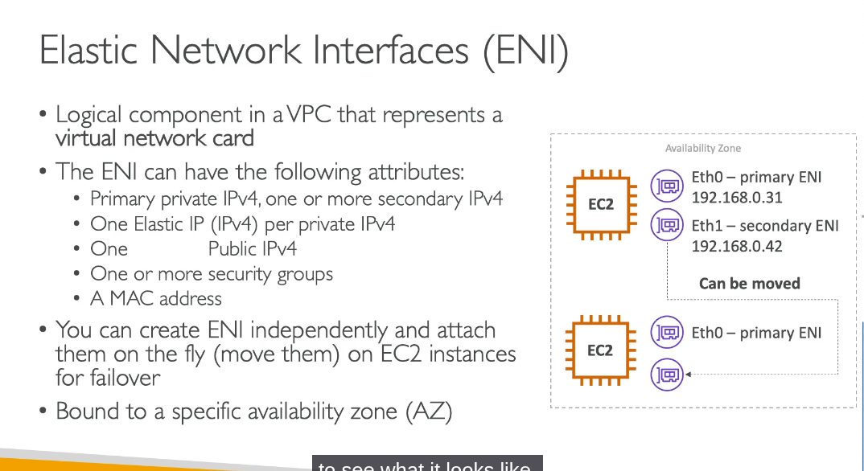

1. **Load Balancers**

**ELB Integrates with:**

AWS Elastic Load Balancing (ELB) integrates with several AWS services to improve availability and scalability:

* Amazon EC2 - Route traffic to your EC2 instances running in the cloud
* Amazon EC2 Auto Scaling - Automatically register/de-register instances as they launch or terminate, and scale based on demand
* AWS Certificate Manager (ACM) - Use SSL/TLS certificates for HTTPS listeners to terminate connections and decrypt requests
* Amazon CloudWatch - Monitor your load balancer performance and set up alarms
* Amazon Elastic Container Service (ECS) - Distribute traffic across containerized workloads
* Amazon Elastic Kubernetes Service (EKS) - Support both Application Load Balancer and Network Load Balancer for Kubernetes workloads
* AWS Lambda - Register Lambda functions as targets (Application Load Balancer only)

ELB also supports registering targets by IP address, allowing you to include targets outside the VPC. For containerized applications, ECS can automatically select unused ports and register tasks with target groups for efficient cluster utilization.

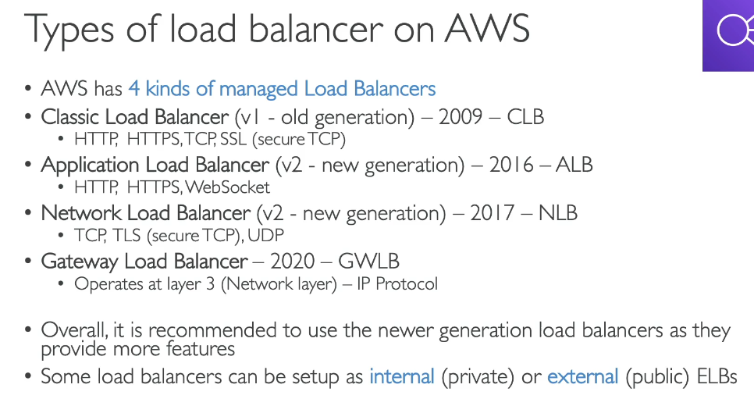

**ALB:**

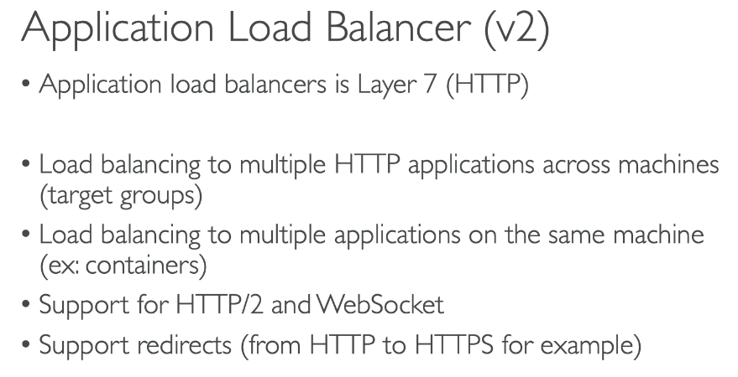

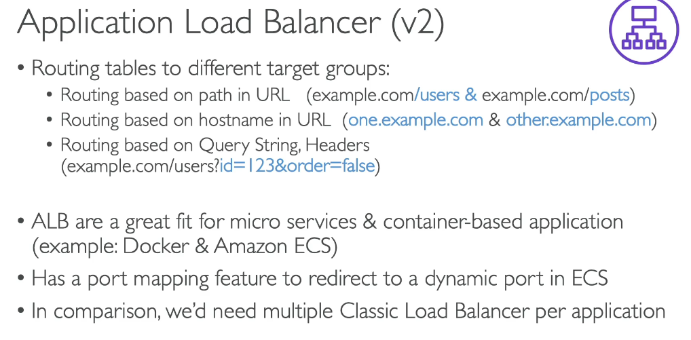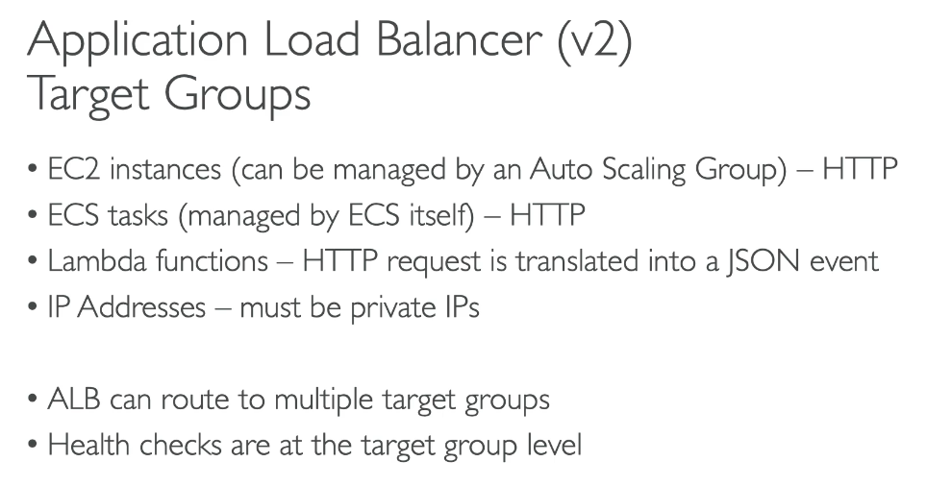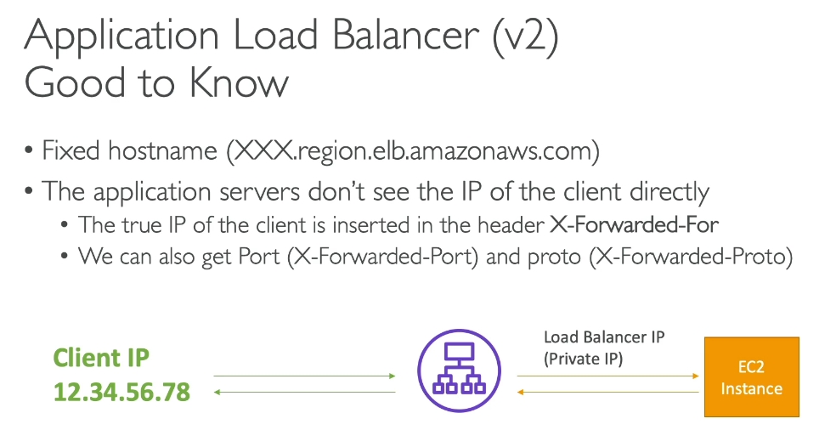**ALB Listener Rule Limits**

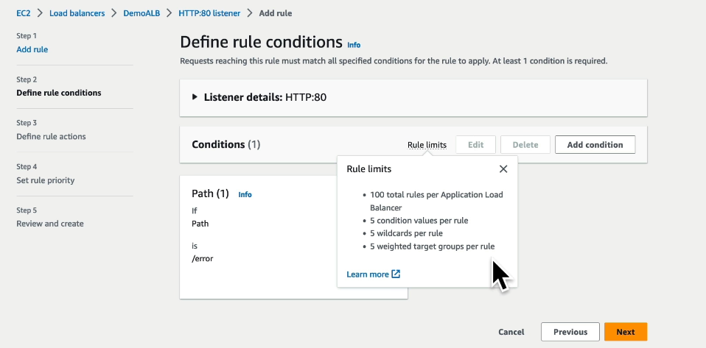

**NLB:**

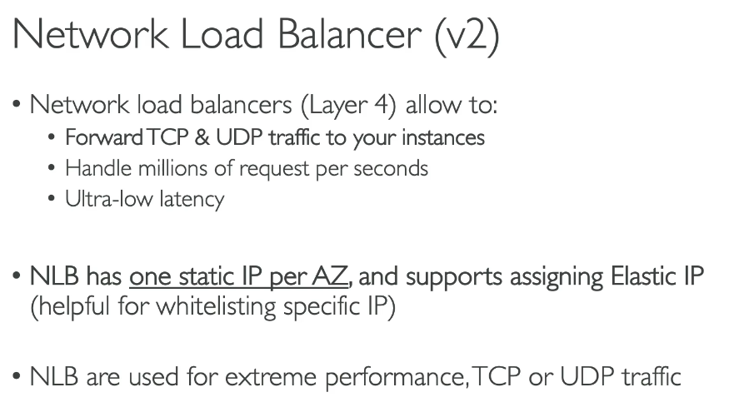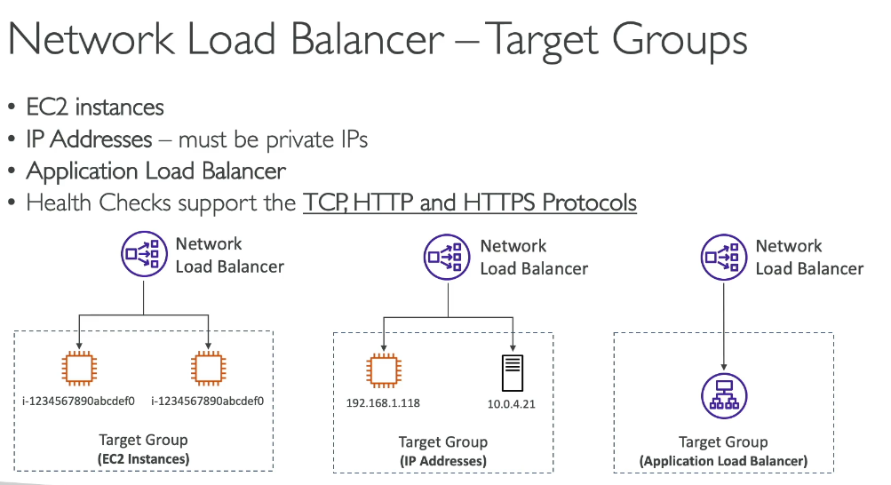

**Gateway Load Balancer:**

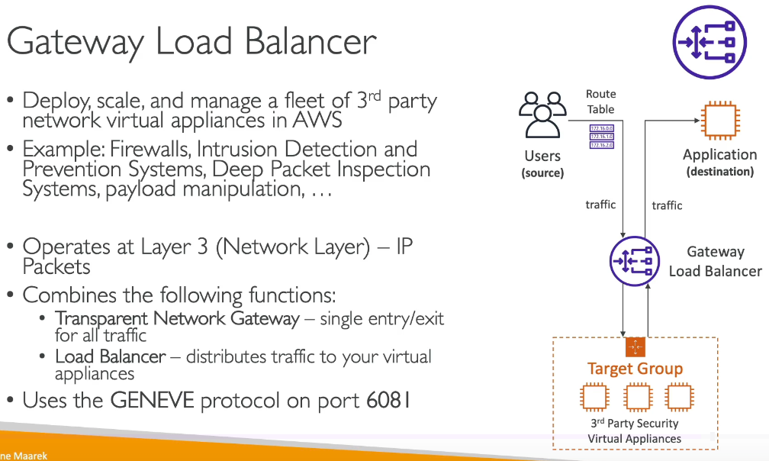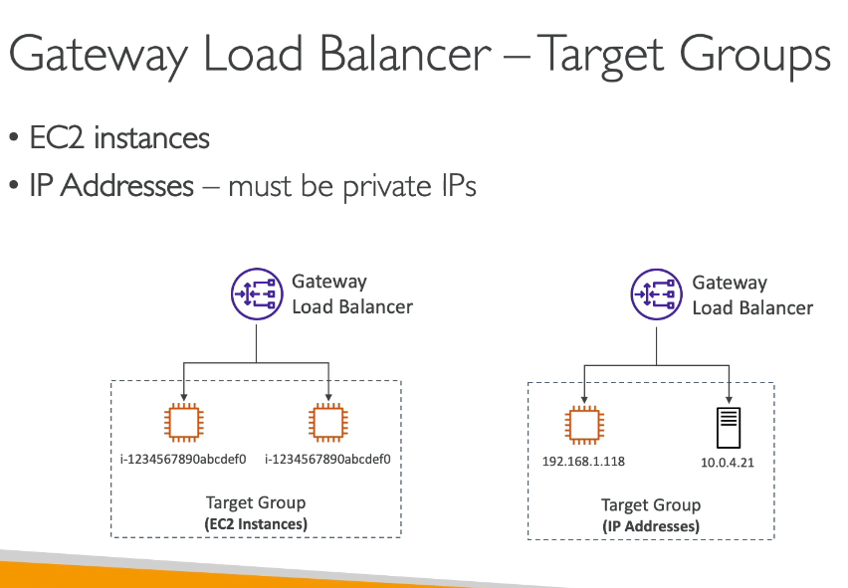

**Sticky Sessions:**

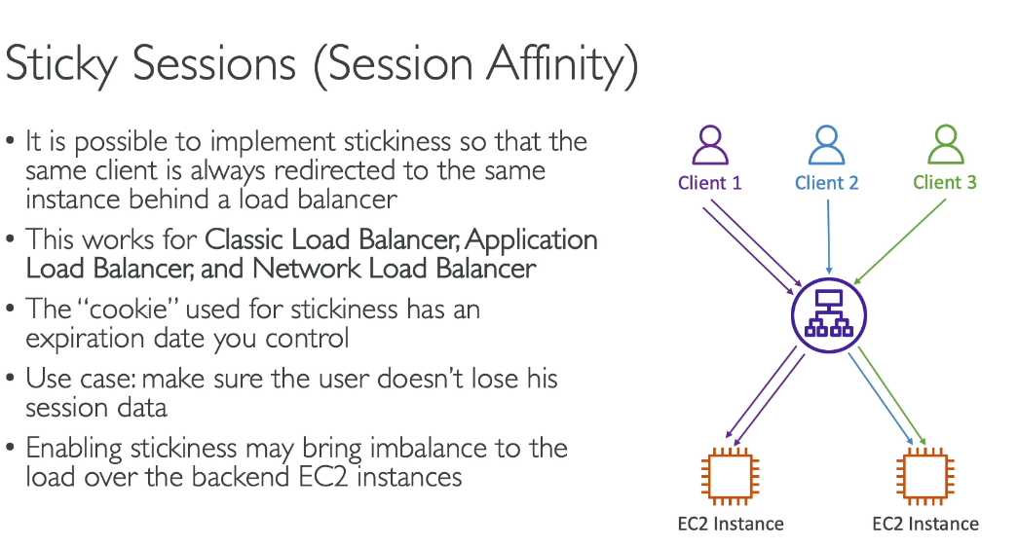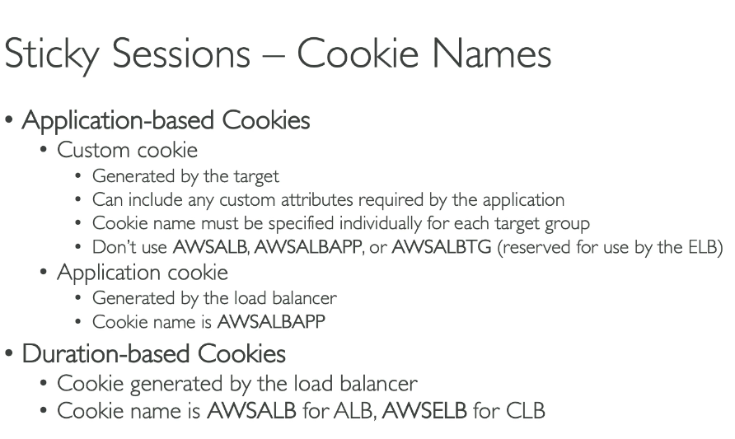

**Cross-Zone Load Balancing:**

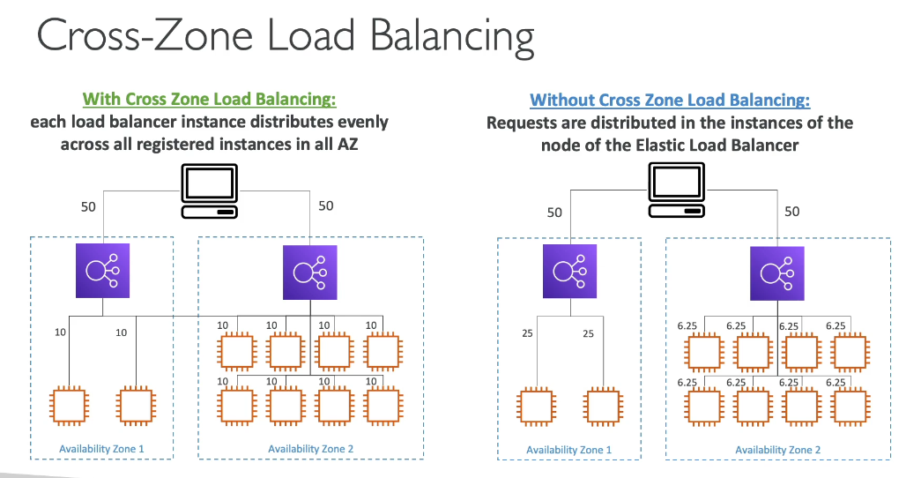

**SSL / TLS:**

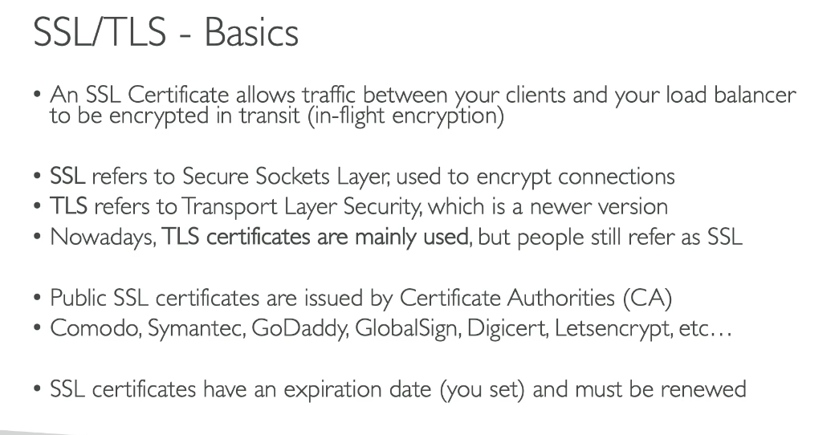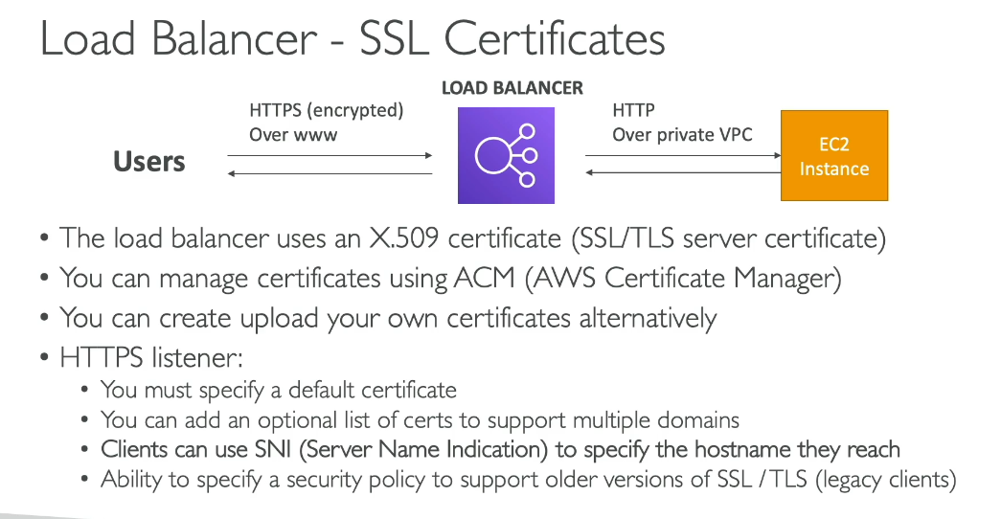

**SNI – Server Name Indication:**

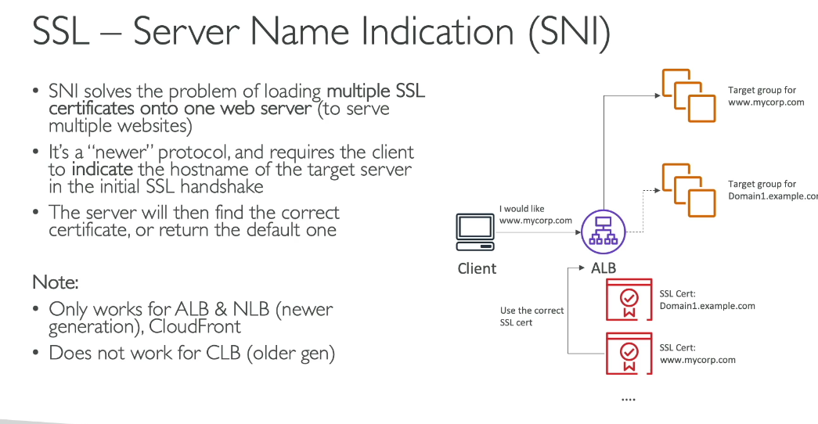

**Connection Draining:**

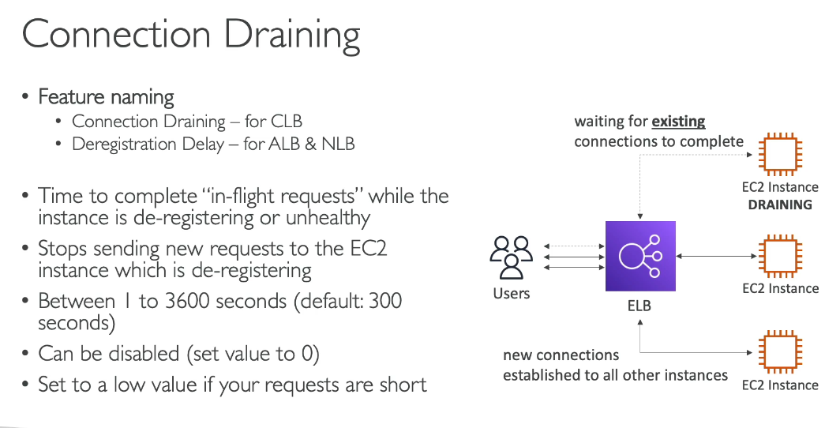

1. **Target Groups**

* Health checks are performed in target groups not in load balancers
* Sticky sessions are performed at target group level

1. **Trust Stores**

Trust Stores in the EC2 console are repositories of Certificate Authority (CA) certificates used to validate client certificates during mutual TLS (mTLS) authentication with Application Load Balancers.

Purpose:

Trust stores enable mutual TLS authentication, where both the client and server authenticate each other using certificates. The trust store contains the CA certificates that your load balancer uses to verify client certificates during the TLS handshake.

Key Features:

1. Certificate Validation - Contains root and intermediate CA certificates that form the chain of trust for authenticating client certificates
2. Certificate Revocation Lists (CRLs) - You can add CRLs to your trust store to specify which certificates should no longer be trusted
3. S3 Integration - CA certificate bundles and CRLs are stored in Amazon S3, and you reference their S3 paths when creating trust stores
4. Sharing Capability - Trust stores can be shared across multiple Application Load Balancers and even shared with other AWS accounts using AWS Resource Access Manager (RAM)
5. Version Control - Supports selecting specific versions of CA bundles and CRLs from S3

When to Use:

* Implementing zero-trust security models
* Requiring client certificate authentication for APIs or applications
* Meeting compliance requirements for mutual authentication
* Securing internal applications with private CA-issued certificates

Trust stores are account-level resources found under Load Balancing > Trust Stores in the EC2 console.

1. **Auto Scaling Group**

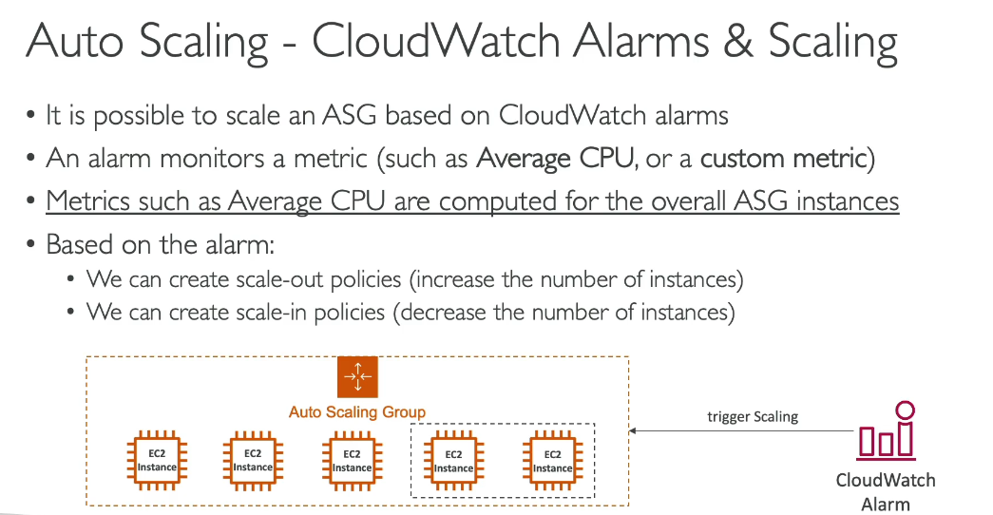

**Scaling Policies:**

Auto Scaling Groups (ASG) support several types of scaling policies:

1. **Dynamic Scaling:**

* Target Tracking Scaling (Recommended)
* Automatically adjusts capacity to maintain a specific metric at a target value
* Example: Keep average CPU utilization at 50%
* Simplest to configure and most commonly used
* Step Scaling
* Scales based on the magnitude of the alarm breach
* Define multiple steps with different scaling adjustments
* Example: Add 1 instance for 50-60% CPU, 2 instances for 60-70% CPU, 4 instances for 70-80% CPU
* More aggressive response to larger breaches
* Simple Scaling
* Adds or removes a fixed number or percentage of instances when an alarm triggers
* Waits for cooldown period before responding to additional alarms
* Less flexible than step scaling

2. Scheduled Scaling

* Scales based on predictable time patterns
* Example: Scale up every Monday at 9 AM for expected traffic increase

3. Predictive Scaling

* Uses machine learning to forecast traffic patterns
* Automatically schedules scaling actions based on predictions

Scaling Adjustment Types:

* Absolute - Add/remove exact number of instances (e.g., add 2 instances)
* PercentChangeInCapacity - Scale by percentage (e.g., increase by 50%)

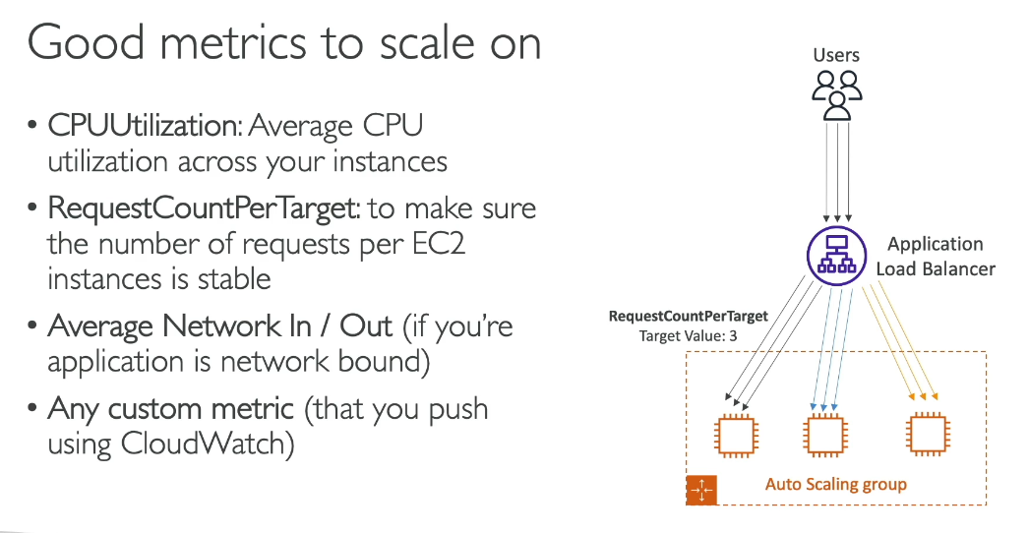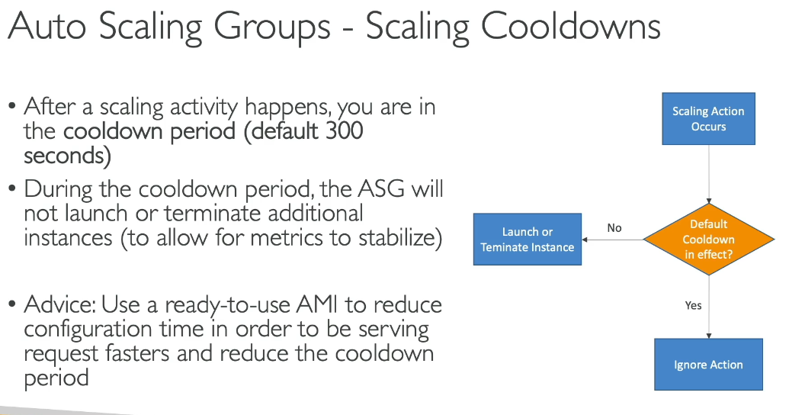

**VPC Lattice Feature/Parameter in ASG Creation:**

VPC Lattice in Auto Scaling Group (ASG):

VPC Lattice is an application networking service that allows you to connect, secure, and monitor services across multiple VPCs and AWS accounts without modifying your code.

How It Works with ASG: When creating an Auto Scaling Group, you can integrate it with VPC Lattice by attaching a VPC Lattice target group. This enables:

* Automatic registration - New EC2 instances are automatically registered to the VPC Lattice target group when they launch
* Health monitoring - VPC Lattice performs health checks on instances and routes traffic only to healthy ones
* Cross-VPC communication - Your ASG instances can communicate with services in other VPCs or accounts seamlessly
* Centralized traffic management - Manage routing, load balancing, and security policies from a single service

Key Benefits:

* Multi-VPC connectivity without complex networking setup
* Service-to-service communication across accounts and regions
* Enhanced security with integrated policies at the network layer
* Simplified management of distributed applications

Use Case Example:

If you have microservices running in different VPCs or accounts, VPC Lattice allows your ASG instances to communicate with those services through a unified networking framework, eliminating the need for VPC peering or Transit Gateway configurations.

1. **Instance Connect Option**
2. **EC2 Instance Store**

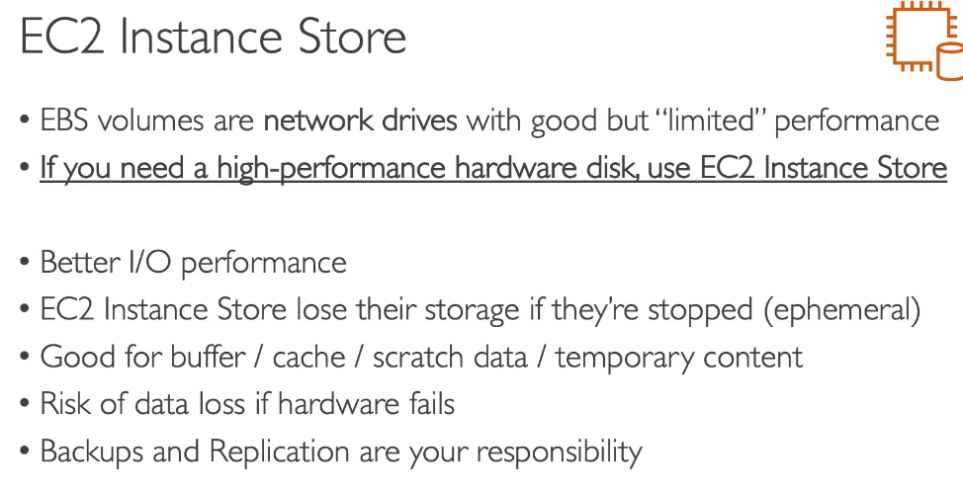

1. **Spot Instance**

* **What It Means**:  
  Spot Instances allow you to purchase unused EC2 capacity at **discounted rates (up to 90%)**. These instances can be interrupted by AWS when the capacity is needed by On-Demand users.
* **Use Case**:  
  Perfect for **non-critical, fault-tolerant workloads**, such as batch processing or machine learning model training.
* **Real-Time Example**:  
  A **video rendering company** needs to process high volumes of video files for clients. By using Spot Instances, they can queue rendering jobs and process them at a fraction of the cost, even if the instances are interrupted and jobs are re-queued.

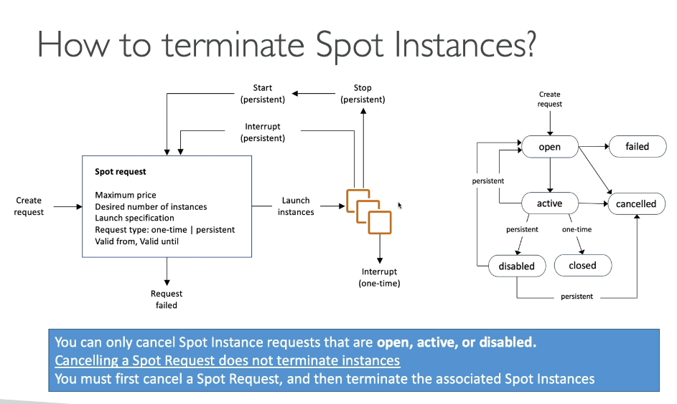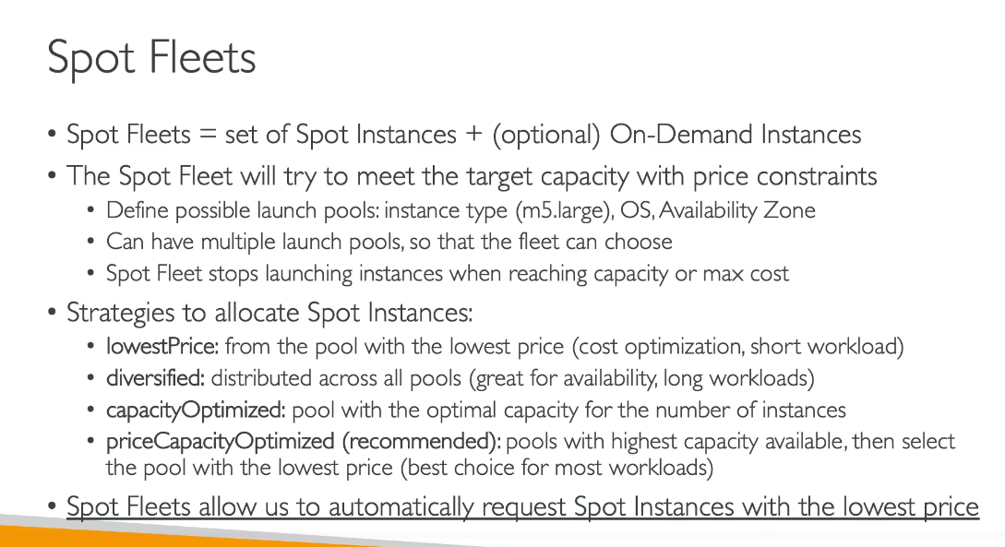

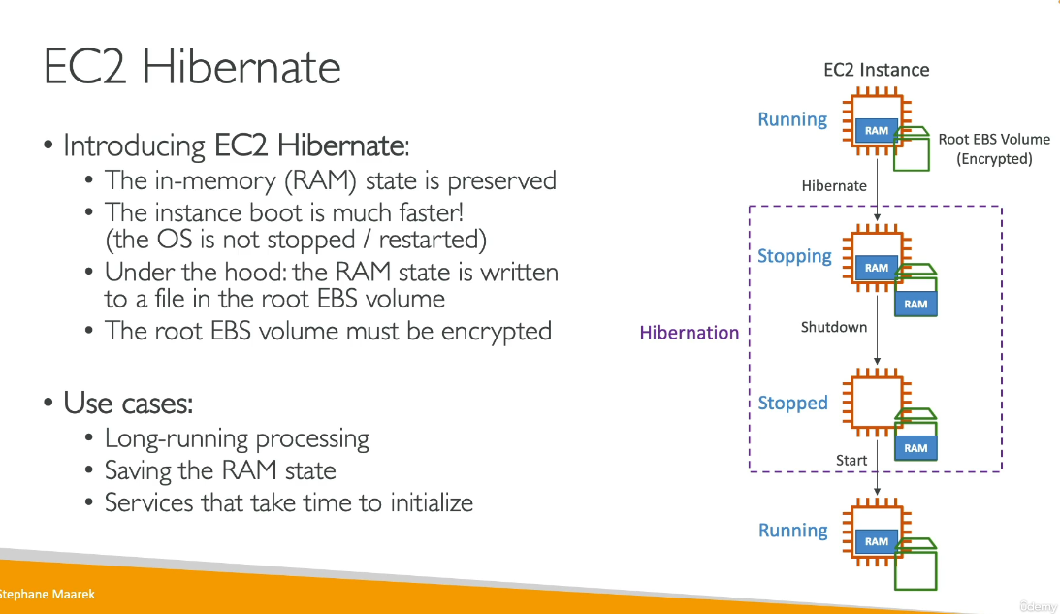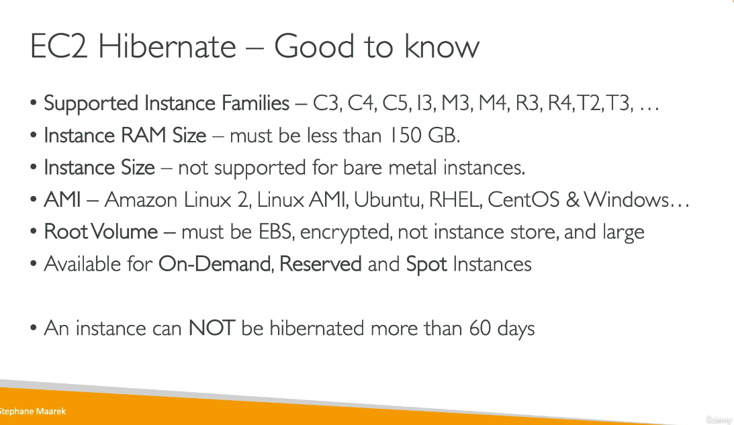

**Udemy Questions:**

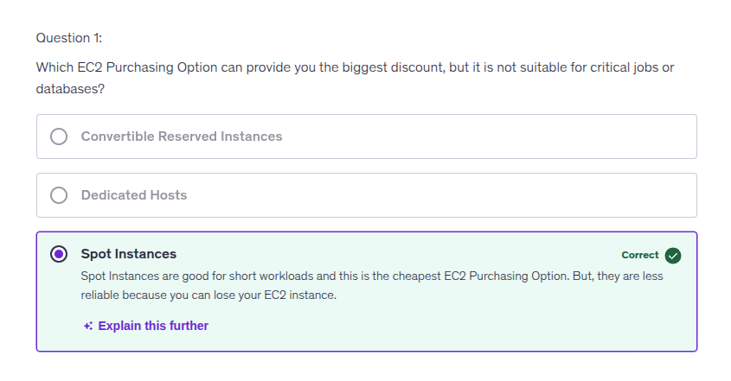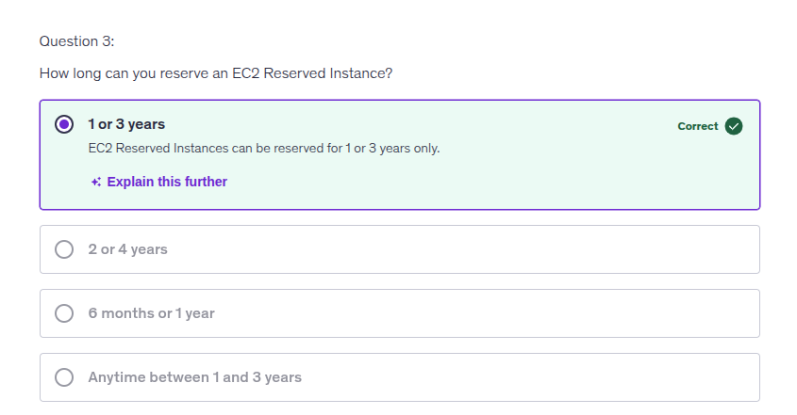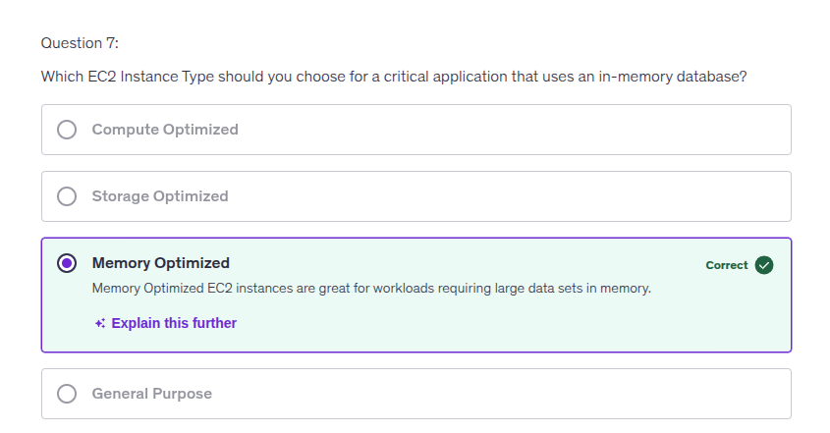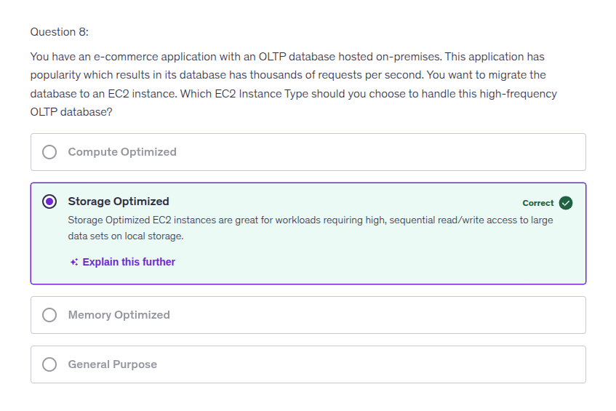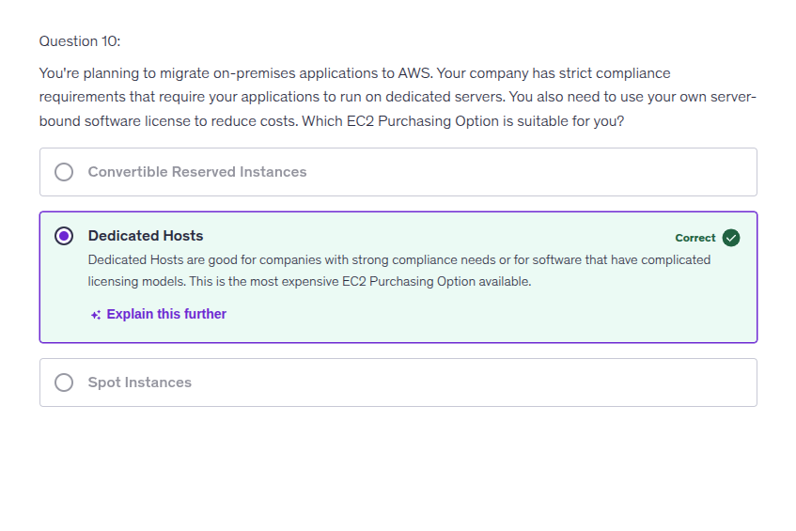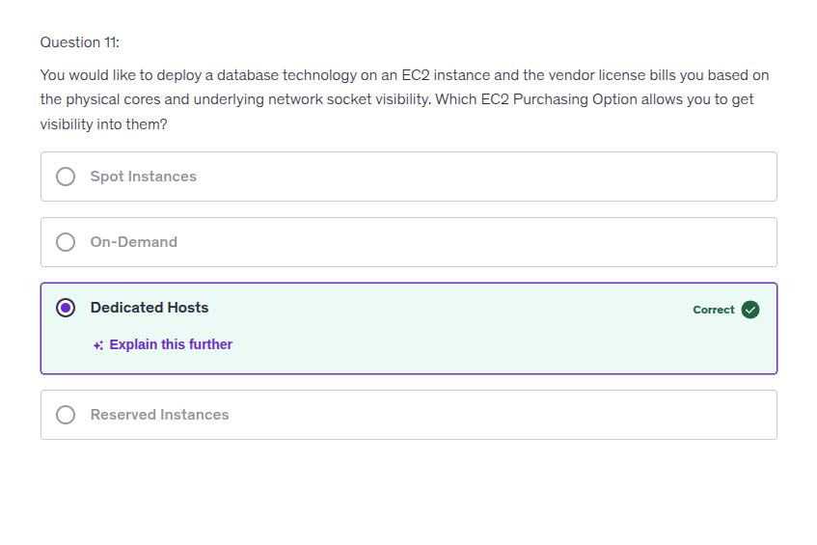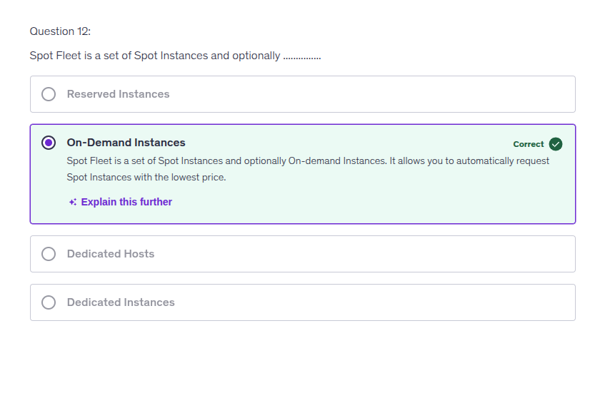  
  
**Quiz – 2:**

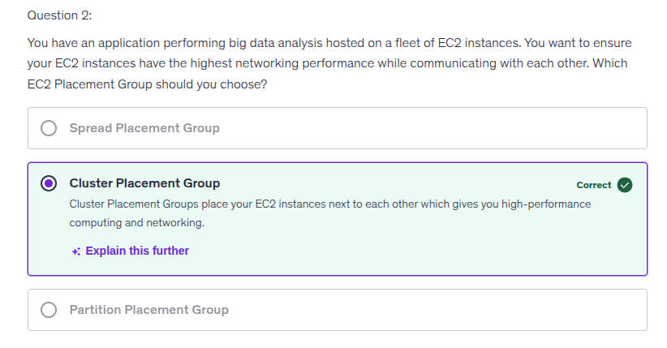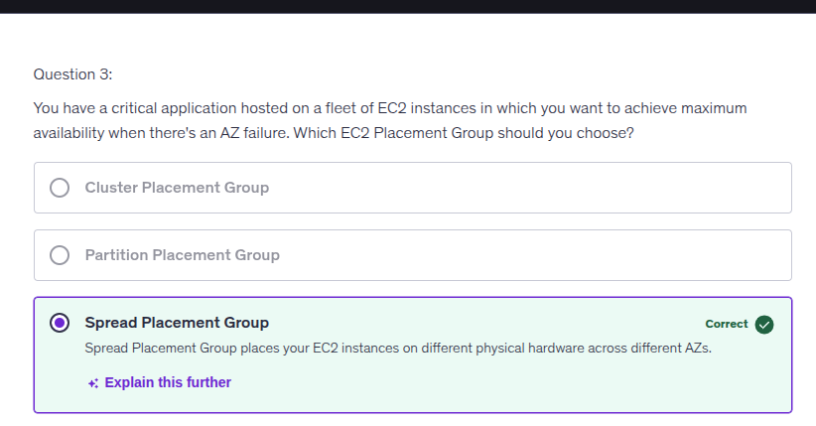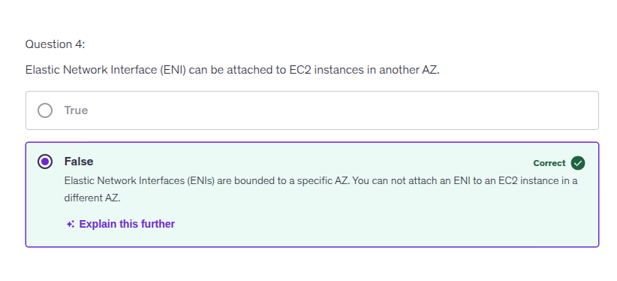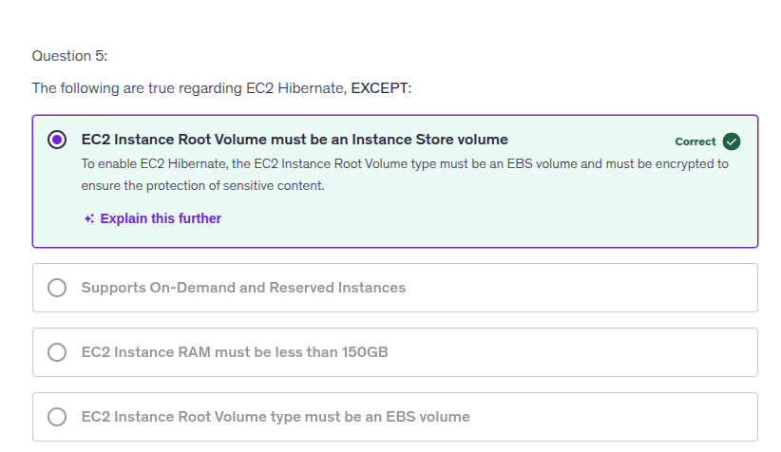

**Quiz-3:**

